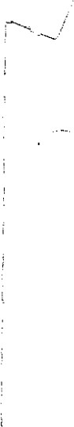Name



Class

# Cell Division

## • Understanding Main Ideas

Fill in the blanks in the table below. Then answer the questions that follow in the spaces provided.

Phases of Mitosis

|  |  |
| --- | --- |
| Phase | Event |
| Prophase | 1. |
| 2. | Chromosomes attach to spindle fibers |
| Anaphase | 3. |
| 4. | New nuclear membranes form |

 5. Which stage of the cell cycle usually lasts longest?

6, During which stage of the cell cycle does DNA replication occur?

7. During which stage of the cell cycle does the cell membrane pinch the cell in two?

## Building Vocabulary

Match each term with its definition by writing the correct letter in the blank.

|  |  |
| --- | --- |
| 10. ______Process in which DNA is copied | c. cell cycle |
| 11. ______Stage of the cell cycle during which the cell’s nucleus divides | d. cytokinesis |

1. _____Regular sequence of growth and division that cells undergo a. interphase
2. _____First stage of the cell cycle b. mitosis

|  |  |
| --- | --- |
| 12. ______Doubled of condensed chromatin | e. replication |
| 13. ______Each identical rod of a chromosome | f. chromosome |

14. ______ Final stage of the cell cycle g. chromatid

THE CELL CYCLE WORKSHEET

Name: ________________

Fill in the blank: Some will be used more than once!!!!!!!!!!

1. Prophase d. Metaphase g. Chromatid j. Spindle fiber
2. Interphase e. Anaphase h. Cytokinesis k. Cell plate
3. Telophase f. Centromere i. Mitosis

1. During what phase of mitosis do centromeres divide and the chromosomes move toward their respective poles?

2. What is the phase where chromatin condenses to form chromosomes?

______________3. What is the name of the structure that connects the two chromatids?

4. In a chromosome pair connected by a centromere, individual chromosome are called?

5. What are the two parts of cell division?

6. What structure forms in prophase along which the chromosomes move?

7. Which phase of mitosis is the last phase that chromatids are together?

8. Which phase of the cell cycle is characterized by a non-dividing cell?

9. What structure is produced when protein fibers radiate from centrioles?

10. What forms across the center of a plant cell near the end of telophase?

11. The period of cell growth and development between mitotic divisions?

The diagram below shows six cells in various phases of the cell cycle. Note the cells are not arranged in the order in which the cell cycle occurs. Use the diagram to answer questions 1-6.

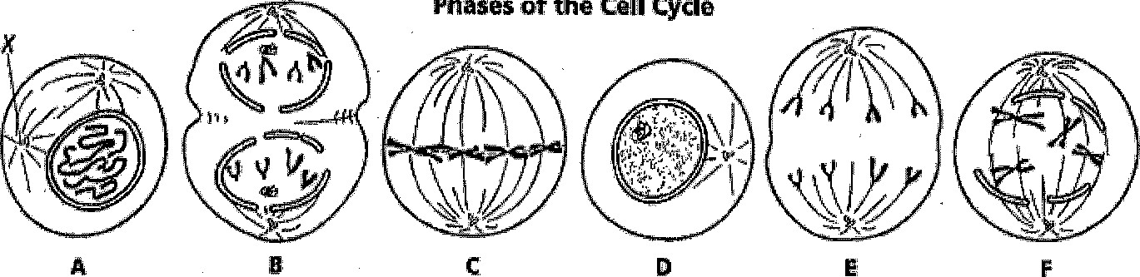

1. In cell A & in cell F there is an early & late stage of the same phase of the cell cycle. What is it?

2. Which cell is in metaphase?

3. Which cell is in the first phase of Mitosis?

4. In the phases picture; what structure is labeled X in Cell A?

5. List the diagrams in order from first to last in the cell cycle: ____ ____ ____ ____ _____ _____

6. Do the cells above depict a plant or an animal cells? (Remember a plant cell has a cell plate)

Name: Date: _____________

The Cell Cycle Coloring Worksheet

1. Label the diagram below with the following labels:

|  |  |
| --- | --- |
| Anaphase Interphase | Mitosis |
| Cell division (M Phase) Interphase | Prophase |
| Cytokinesis Interphase | S-DNA replication |
| G1 - cell grows Metaphase  G2 - prepares for mitosis | Telophase |

1. Next you will label the diagram. Lightly color the G1 phase BLUE,

the S phase YELLOW, the G2 phase RED, and the stages of mitosis ORANGE. Color the arrows indicating all of the interphases in GREEN.

Color the part of the arrow indicating mitosis PURPLE and the part of the arrow indicating cytokinesis YELLOW.

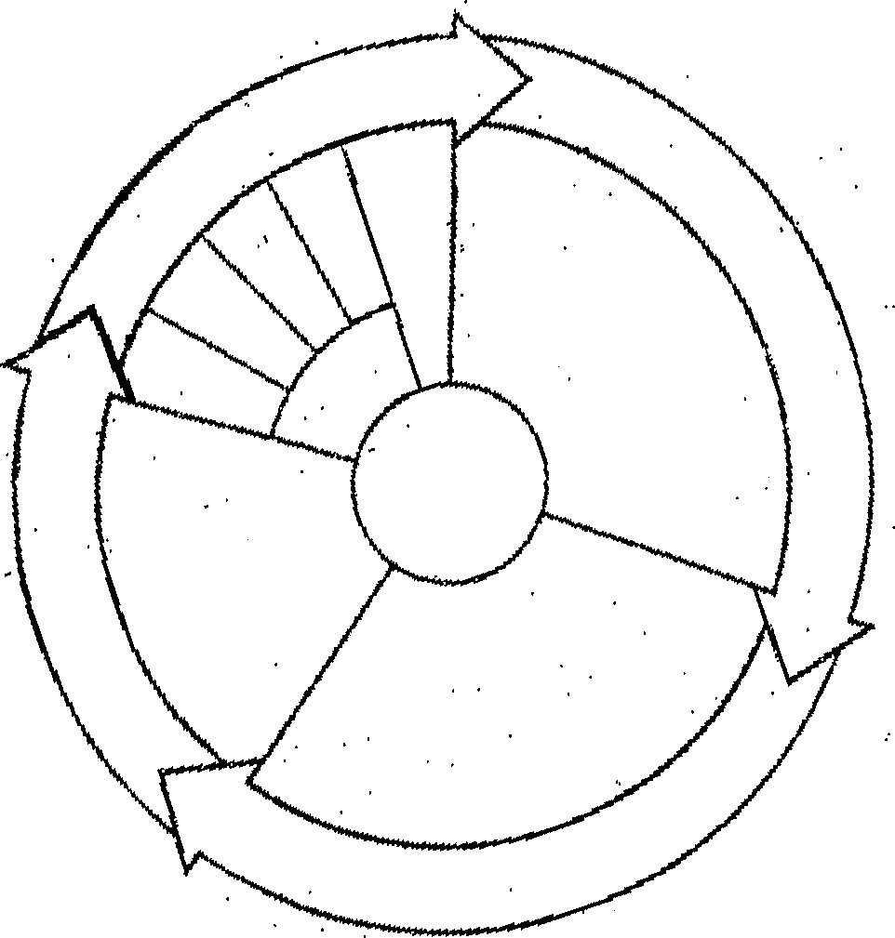

## Stages of Cellular Division

Directions: Number the following six stages of cell division in animal cells in the proper order. Then label each stage (interphase, prophase, metaphase, anaphase, telophase, or cytokinesis).

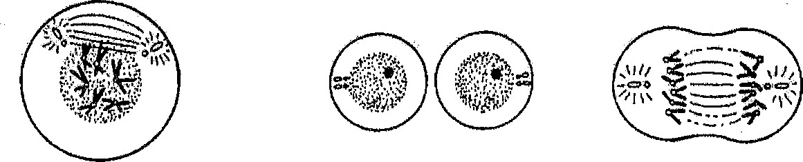



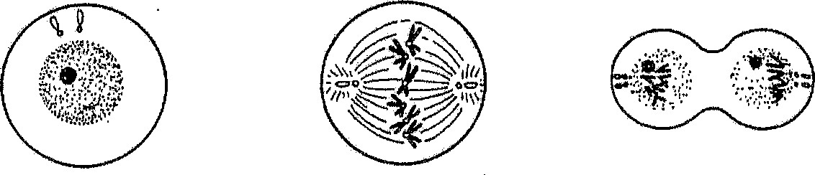



Directions: Do the same for the plant cell below. Also label the cell plate!

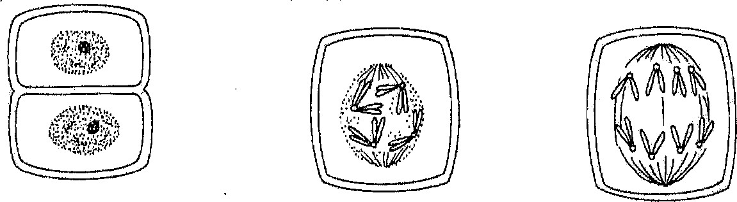



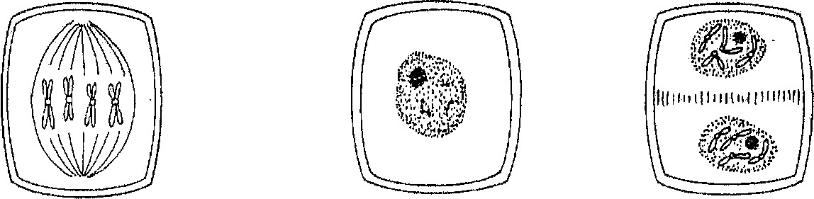



Mitosis Notes = Cell division occurs in a series of stages or phases.

1st: INTERPHASE • Chromosomes are copied (# doubles)

* 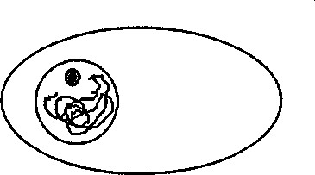Chromosomes appear as thread-like coils (chromatin) at the start, Each chromosome and its copy (sister chromosome) change to sister chromatids by end of this phase

|  |  |
| --- | --- |
|  | Sister Chromatids Centromere |
| 2nd: PROPHASE | • Mitosis begins (cell begins to divide) |

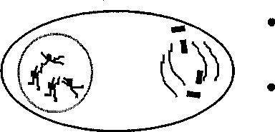Centrioles (or poles) appear and begin to move to opposite ends of cell

Spindle fibers form between the poles

|  |  |
| --- | --- |
| 3rd: METAPHASE | • Chromatids (or pairs of chromosomes) attach to the |

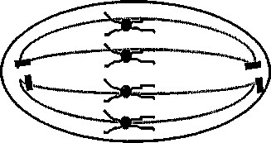 spindle fibers

Sister Chromatids

|  |  |
| --- | --- |
| 4th: ANAPHASE | • Chromatids (or pairs of chromosomes) separate and |
|  | and begin to move to opposite ends of the cell |

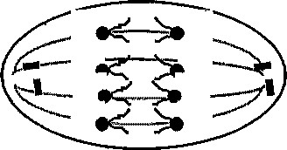

5th: TELOPHASE Two new nuclei form

Chromosomes appear as chromatin threads, not as rods)

* Mitosis ends

Cell membrane moves inward to create two daughter cells each with its own nucleus with identical chromosomes!

Mitosis Notes Name: _____________

___________ _____________occurs in a series of stages or _______

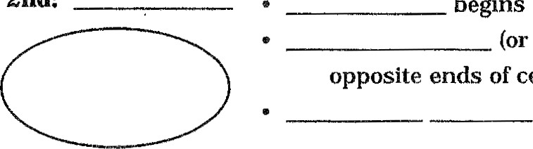1st:____________ Chromosomes are ___________________(or doubled

Chromosomes appear as threadlike coils ( _______________) at the

beginning, but each chromosome & its copy (___________ chromosome) -----> change to sister chromatids at the end of this phase

Sister chromatid

2nd: ___________ ___________ begins (cell begins to divide)

 _________________ (or poles) appear & they begin to move to

the opposite ends of the cell

___________ ____________form between the poles

3rd: _____________ _______________ (or pairs of chromosomes) attach to the

 spindle _____________

Sister chromatids

Chromatids are lined up in the _____________ of the cell

4th: ______________ Chromatids (or pairs of chromosomes) ____________ and

 begin to move to ____________________ ends of the cell

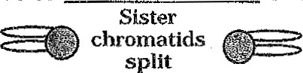

5th: Two new _____________________ cells are then formed

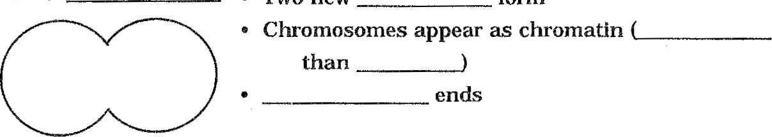

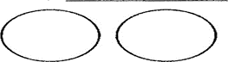6th:

Cell membrane moves inward to create two new ______________

cells . Each new cell then has its own ___________(brain of cell)

and chromosomes that are ________________